**PRACTICAL NO : 9**

**Deep Generative Models**

**AIM: Set up a generator network to produce samples and a discriminator network to distinguish between real and generated data. (Use a simple small dataset)**

**Code:**

import tensorflow as tf

from tensorflow.keras import layers, models

import numpy as np

import matplotlib.pyplot as plt

# Load the MNIST dataset

(X_train, _), (_, _) = tf.keras.datasets.mnist.load_data()

X_train = X_train.astype('float32') / 255.0 # Normalize to [0, 1]

X_train = np.expand_dims(X_train, axis=-1) # Add channel dimension (28x28x1)

# Create the generator

def build_generator():

model = models.Sequential()

model.add(layers.Dense(256, input_dim=100))

model.add(layers.LeakyReLU(0.2))

model.add(layers.BatchNormalization(momentum=0.8))

model.add(layers.Dense(512))

model.add(layers.LeakyReLU(0.2))

model.add(layers.BatchNormalization(momentum=0.8))

model.add(layers.Dense(1024))

model.add(layers.LeakyReLU(0.2))

model.add(layers.BatchNormalization(momentum=0.8))

model.add(layers.Dense(28 * 28 * 1, activation='tanh')) # Output is 28x28 image

model.add(layers.Reshape((28, 28, 1)))

return model

# Create the discriminator

def build_discriminator():

model = models.Sequential()

model.add(layers.Flatten(input_shape=(28, 28, 1)))

model.add(layers.Dense(512))

model.add(layers.LeakyReLU(0.2))

model.add(layers.Dense(256))

model.add(layers.LeakyReLU(0.2))

model.add(layers.Dense(1, activation='sigmoid')) # Binary output (real or fake)

return model

# Build the GAN (stacking the generator and discriminator)

def build_gan(generator, discriminator):

discriminator.trainable = False # Freeze the discriminator during GAN training

model = models.Sequential()

model.add(generator)

model.add(discriminator)

return model

# Instantiate the models

generator = build_generator()

discriminator = build_discriminator()

# Compile the discriminator

discriminator.compile(optimizer='adam', loss='binary_crossentropy', metrics=['accuracy'])

# Compile the GAN

gan = build_gan(generator, discriminator)

gan.compile(optimizer='adam', loss='binary_crossentropy')

# Training the GAN

epochs = 10000

batch_size = 64

half_batch = batch_size // 2

# Labels for real and fake images

real_label = np.ones((half_batch, 1))

fake_label = np.zeros((half_batch, 1))

for epoch in range(epochs):

# Train discriminator with real images

idx = np.random.randint(0, X_train.shape[0], half_batch)

real_images = X_train[idx]

d_loss_real = discriminator.train_on_batch(real_images, real_label)

# Train discriminator with fake images (generated)

noise = np.random.normal(0, 1, (half_batch, 100)) # Random noise

fake_images = generator.predict(noise)

d_loss_fake = discriminator.train_on_batch(fake_images, fake_label)

# Compute the total discriminator loss

d_loss = 0.5 * np.add(d_loss_real, d_loss_fake)

# Train the generator (we only train the generator in the GAN model)

noise = np.random.normal(0, 1, (batch_size, 100)) # Random noise for GAN input

g_loss = gan.train_on_batch(noise, real_label) # We want the generator to fool the discriminator

# Print the progress

if epoch % 1000 == 0:

print(f"Epoch: {epoch} | D Loss: {d_loss[0]} | G Loss: {g_loss}")

# Save generated images at intervals

if epoch % 5000 == 0:

noise = np.random.normal(0, 1, (16, 100))

generated_images = generator.predict(noise)

fig, axs = plt.subplots(4, 4, figsize=(4, 4))

cnt = 0

for i in range(4):

for j in range(4):

axs[i, j].imshow(generated_images[cnt, :, :, 0], cmap='gray')

axs[i, j].axis('off')

cnt += 1

plt.savefig(f'gan_images_epoch_{epoch}.png')

plt.close()

OutPut:

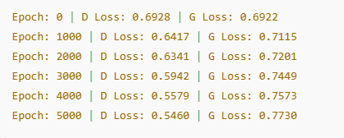

**PRACTICAL NO : 10**

**AIM: Develop an API to deploy your model and perform predictions**

**import** pandas **as** pd

**import** numpy **as** np

df**=**pd**.**read_csv('BankNote_Authentication.csv')

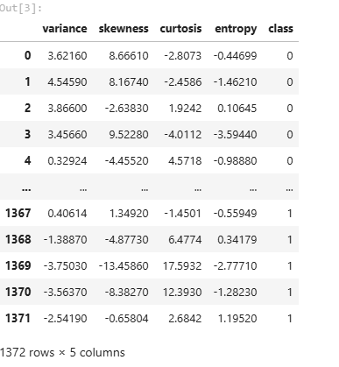

*### Independent and Dependent features*

X**=**df**.**iloc[:,:**-**1]

y**=**df**.**iloc[:,**-**1]

X**.**head()

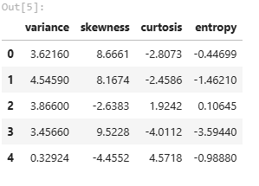

y**.**head(20)

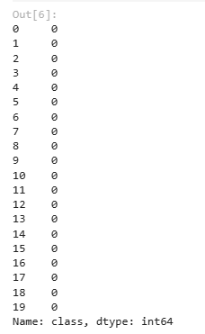

*### Train Test Split*

**from** sklearn.model_selection **import** train_test_split

X_train,X_test,y_train,y_test**=**train_test_split(X,y,test_size**=**0.3,random_state**=**0)

*### Implement Random Forest classifier*

**from** sklearn.ensemble **import** RandomForestClassifier

classifier**=**RandomForestClassifier()

classifier**.**fit(X_train,y_train)

RandomForestClassifier()

*## Prediction*

y_pred**=**classifier**.**predict(X_test)

*### Check Accuracy*

**from** sklearn.metrics **import** accuracy_score

score**=**accuracy_score(y_test,y_pred)

score



*### Create a Pickle file using serialization*

**import** pickle

pickle_out **=** open("classifier.pkl","wb")

pickle**.**dump(classifier, pickle_out)

pickle_out**.**close()

**import** numpy **as** np

classifier**.**predict([[2,3,4,1]])

